Introduction

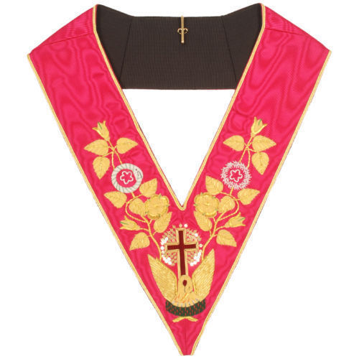
The Ancient & Accepted Rite is an Order of Freemasonry comprising a total of 33 degrees of which the Rose Croix is the 18th Degree.

Local bodies of the Order are known as Rose Croix Chapters and all business is conducted in the 18th Degree, including the Admission of Candidates (known as ‘Perfection’) and the Enthronement of the Most Wise Sovereign (the equivalent of Master in a Craft Lodge).

History

The Ancient & Accepted Rite originated in France in the mid-1700s as a ‘Rite of Perfection’ consisting of 25 so-called ‘higher’ degrees and spread via the trade routes to the West Indies and North America.

There are now over 60 Supreme Councils – the independent governing bodies of the Order – throughout the world.

The Supreme Council 33° of the Ancient & Accepted Rite for England and Wales and its Districts and Chapters Overseas was established in 1845 under a Patent issued by the Northern Masonic Jurisdiction of the USA. The Supreme Council consists of nine eminent members of the Order, all holders of the 33rd Degree.

The Grand Patron is HRH The Duke of Kent, KG, Grand Master of the United Grand Lodge of England, reflecting the close links between the Craft and the Ancient & Accepted Rite.
Administration

The Ancient & Accepted Rite has a very flat structure and there is no equivalent to a Grand Lodge or Provincial Grand Lodge in the Order.

Chapters are organised into Districts in England and Wales, each under the jurisdiction of an Inspector General who is appointed by the Supreme Council to have charge and supervision over the Chapters in his particular District.

The Inspector General is the representative of the Supreme Council in his District and is responsible for upholding the authority of the Council and the dignity of the Order.

An Inspector General is authorised to appoint a District Recorder to assist him with the secretarial and administrative duties in his District.

Membership

A candidate seeking membership must be of high moral standing, be prepared to sign a declaration that he professes the Trinitarian Christian Faith and have been a Master Mason of at least a year’s standing at the time of his election. There are no other qualifying criteria.

A common misconception is that the Ancient & Accepted Rite is an ‘invitational’ Order and that candidates must wait to be approached to be considered for membership. Such is not the case and enquiries from any applicant meeting the qualifying criteria will be most welcome.

The Degrees

Candidates are admitted in the 18th Degree, after the intermediate degrees from the 4th to the 17th inclusive have been conferred ‘by name’ in a preliminary ceremony. The three degrees of Craft Masonry are accepted as equivalents of the first three degrees of the Ancient & Accepted Rite and as such are not worked in Rose Croix Chapters.

The 18th Degree is undoubtedly one of the most impressive of all the degrees in Freemasonry. The Candidate is conducted on a mystical journey during which he discovers the virtues of Faith, Hope and Charity. After a period of contemplation he is conducted from the abyss of darkness into the light and the recovery of the lost Word and is made a Knight of the Pelican and Eagle and a Prince of the Order of the Rose Croix of Heredom.

The Higher Degrees are conferred by the Supreme Council at special ceremonies held in London and occasionally elsewhere in the UK and Overseas.

Past Sovereigns who have undertaken all sections of the 18th Degree and Enthroned their successor are eligible for the 30th Degree. Inspectors General may recommend promotions to the 31st and 32nd Degrees in cases where Brethren have rendered outstanding service to the Order – membership of these two degrees is, however, strictly limited.

The 33rd Degree is conferred only on members and senior officials of the Supreme Council, Inspectors General and a small number of very distinguished members of other Masonic Orders.
Chapters in North East Lancashire
(visit the District Website for meeting patterns/dates)

St. Peter’s Chapter No.31
Masonic Hall, Institute Street, Bolton BL1 1PZ

James D Murray Chapter No.197
Masonic Hall, Moor Lane, Padiham BB12 8LZ

Verney Clayton Chapter No.261
Masonic Hall, Adelaide Street, Accrington BB5 2BE

Bethel Chapter No.290
Masonic Hall, Ashday Lea, Rawtenstall BB4 6QX

Accrington Chapter No.364
Masonic Hall, Adelaide Street, Accrington BB5 2BE

Bury Chapter No.435
Masonic Hall, Parsons Lane, Bury BL9 0LY

Emmanuel Chapter No.447
Masonic Hall, Institute Street, Bolton BL1 1PZ

Rochdale St. Chad Chapter No.494
Masonic Hall, Richard Street, Rochdale OL11 1DU

William Horrocks Chapter No.603
Masonic Hall, Hawkshaw Avenue, Darwen BB3 1QZ

Colne St. Bartholomew Chapter No.1073
Masonic Hall, 91 Albert Road, Colne BB8 0BS
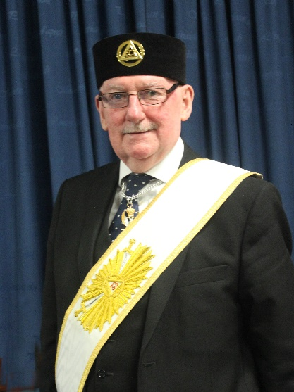

V∴Ill∴Bro. Alexander S McLaren 33°
Inspector General
For the District of North East Lancashire

For further information and guidance on selecting a suitable Chapter for membership, please contact the District Recorder for North East Lancashire:

Illustrious Bro. Alan Jones, 31°

Email: Alan.jones15@Outlook.com

Telephone: 07740 578613

Other Sources of Information

Supreme Council
http://sc33.org.uk

North East Lancashire District Website
https://rosecroixeastlancs.org/

January 2024

The Supreme Council 33° of the Ancient & Accepted Rite for England and Wales and its Districts and Chapters Overseas

Sovereign Grand Commander
V∴P∴Bro John Boyington 33°

District of North East Lancashire
Inspector General
V∴Ill∴Bro. Alexander S McLaren 33°

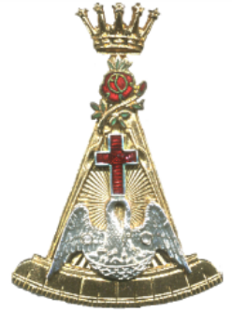

Rose Croix
Your next step in Freemasonry?

